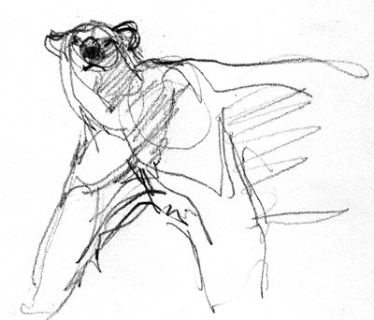
Plant Biology Syllabus

Welcome to Plant Biology! I would like to share some important information so that this will be a positive year for everyone.

Teacher: Mrs. Jackson, email: kristinejackosn@hasd.org

Textbooks: Holt Biology by Johnson and Raven and various online and printed
materials to be distributed as the course progresses

Course Description: Plant Biology is a High School level course designed to increase your knowledge of scientific topics related to the study of plants. We will learning about plant structure, development, reproduction and its role in our ecosystem. This year you will also gain or improve on valuable life skills such as: questioning what you see, technological know-how, citizen action and problem solving. Science is an incredible avenue for these types of explorations. I am committed to your education and I love my job.

Materials: You must bring these things with you everyday!
- Textbook
- Workbook/ 3 ring binder
- 1-subject notebook
- Pencil
- Student passbook
Other useful but not required supplies: calculator, colored pencils, compass, protractor

Participation:
I am giving you the benefit of the doubt. I think you are going to like it here and want to participate. I also believe that every student can give frequent, meaningful and constructive contributions. Here are some examples of what I consider appropriate behavior:

- Using appropriate language and listening. Be a good listener when others are talking. Use positive language!! (no foul language, derogatory or racial comments, inappropriate or disrespectful behavior)
- Participating in labs, class activities, videos, and class discussions.
- Following lab safety rules (such as wearing goggles).
- Displaying proper use of class work time. (no texting or using phones unless asked to do so. If I see your phone…I will collect it.)
- Working in a group setting.
- Cleaning your lab station and glassware. All materials should be cleaned and returned to the original set up.
- Staying in seat until excused. (No “lining up” by the door.)

Labs:
Laboratory policy: INAPPROPRIATE BEHAVIOR IN THE LABORATORY IS VERY DANGEROUS. IF THIS HAPPENS, NO WARNINGS WILL BE GIVEN. YOU WILL BE ASKED TO SIT DOWN AND YOU WILL LOSE ALL POINTS FOR THAT LAB AND FURTHER DISCIPLINARY ACTION WILL BE TAKEN AS NECESSARY. THIS IS A ZERO TOLERANCE ZONE.
- You will be assigned lab groups.
- Sometimes you will turn in labs stapled together with your group and sometimes they will be handed in independently.
- Your lab will be graded as a group if it is turned in as a group. Questions will be selected randomly off of each person’s lab to be graded. Be sure to discuss each answer thoroughly.

Attendance:
Attending class is vital to your success. Be here every day! If you know you will be absent, make plans and inform me ahead of time. This is important!! If you are going to miss class due to athletics, a field trip for another class, a guest speaker, Be Prepared and Be Responsible!

Extended Learning Time:
If objectives are not met each week on formative assessment quiz, then you will be selected to attend ELT for support and review.

Make-Up Work:
If you are absent when assignments are due, when lab activities are done, or when quizzes or exams are given, you will be expected to complete this work the day you return to school. See your teacher for assignments you have missed.

- Late work will be accepted ONLY during the chapter/unit in which it was assigned.
- On all late work you will receive credit for 50% of the number correct.
- Sometimes alternate assignments will be given in place of labs, videos, or other hard to make up assignments.

Grading Scale:
100-97% A+ 89-87% B+ 79-77% C+ 69-67% D+
96-93 % A 86-83% B 76-73% C 66-63% D
92-90% A- 82-80% B- 72-70% C- 62-60% D-
59-0% F
Categories and percentages:
Tests 65%
Labs /Lab Reports 20%
Projects/Homework/Journals 15%

- Each semester is worth 45% of your semester grade.
- Your semester exam is worth 10%.
- Cheating will not be tolerated and will result in a ZERO on any test, quiz, lab, or homework assignment for both parties involved. (THIS INCLUDES COPYING SOMEOME ELSE’S WORK AND PLAGIARISM.) In addition, your parent/guardian and administration may be informed.

